Tutorials For Beginners

To understand particular tech we need to go thru this steps:

**Step 1**. **What N Why?:** MuleSoft as a product and why it’s needed

**Step 2**. **Understanding** **How it Benefits(Understanding Complete Lifecycle) :** Every technology has it’s own life cycles so same way we should know the MuleSoft API lifecycle

**Step 3**. **Understanding Where To Implement**: Now, you have theoretical knowledge  of MuleSoft API lifecycle, let’s checkout the same in action

**Step 4**. **Installations n Hands-on POCs:**Now you poses good understanding of MuleSoft, let’s have all tools to start with

**Step 5**. **Certification:-**Go through MuleSoft online training for certification available free of cost or schedule Interview to get a job…

* **Disadvantage of Point-to-point connection or integrations:**

Let say we are one org n to manage our business we use 4 systems like A.salesforce(CRM)

B. SAP(ERP)

C. SqL Db(Relational Db)

D. Servicenow(Ticketing Tool) n we have point-to-point integrations where each system connected with each other so we face below problem:

**Complexity**: If any change in A system need to be change in all B,C,D system

**Rigid Architecture**: No space for change

**Reliability** – if one of the system fail then there is no reliable way of putting that system out of network and all communication with the system will be lost

**Tightly Coupled** – each system is connected with all other system so change in one system need a change in many different system

* **Mulesoft as middleware system** will act as single point of system/platform through which any application within organization can exchange or share their data/information with another application. This removes the point to point integration complexities and challenges.

Advantages –

* Remove earlier complexities of point to integration
* Expose existing system functionalities as services within organization
* Comes with reliability pattern for integrations
* More agile – provide flexibility if there is a change required
* **MuleSoft API lifecycle** tell us how effectively and efficiently we can use MuleSoft Anypoint platform while going through different stages of API lifecycle. Anypoint platform provide us all the required tools and features to develop and maintain APIs within organization.

Below is the lifecycle which MuleSoft suggest

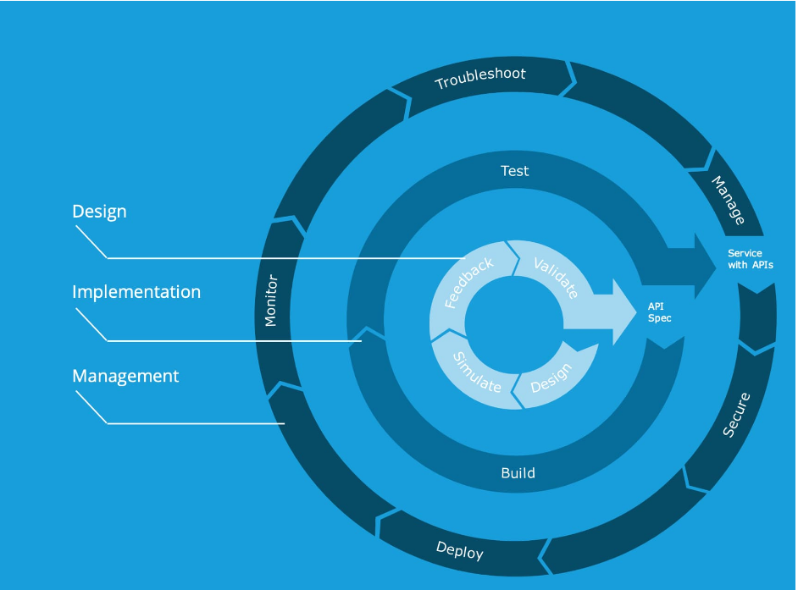

API lifecycle start with the requirement where a team/organization come up with their business need for integration. MuleSoft development team analyse the requirement and come up with the proper implementation architecture. MuleSoft suggest API led approach for implementation.

Assuming all requirements are clear and required documents like High Level Design, Service Level Design and Mapping sheets are already created for the API.

Below are the different phases in API Lifecycle

We can categories all lifecycle stages into 3 stages  
**Design includes Design,Simulate,Feedback,Validate state**

* **Design:** Identify process and business requirements, create logical data model, translate into logical service, API groupings
* **Simulate:** Define API resources, Define API operations/methods, Define request/response payload/Http codes
* **Feedback:** Mock up the API, publish interactive console, create notebook use cases, receive feedback
* **Validate:** Modify API design as appropriate based on developer feedback, continue to validate

The Result/Outcome of Design Stage is that we get API Specification Created n ready to be imported for building/development in Anypoint studio.

**Implementation includes Build And Test state**

* **Build:** Once the API spec is ready we can import it into anypoint studio n start building the ule app based on the requirements given by client
* **Test:** Once Build is done, We can test the mule app for its correctness n workingness for the asked functionality by running the app in anypoint studio, debugging if any issues n solving n using Munit.

**Management** includes Deploy,Monitor,Troubleshoot,Secure State

* Mulesoft API Lifecycle – Use Case

**Business Functional** **Requirement – Surya Mobile co.** team come with a requirement that they need an interface which can accept the order placed from the mobile application and can also provide the user’s order details in case they need at any time.

**NFR (Non Functional Requirement) –** Mobile team want to use basic authorization for calling the service and the response should be in 5 sec max.

Mulesoft Developer/MuleSoft team/consultant looks into the requirement and will start with the API specification. Here team needs to provide interface for order management. API will provide user’s order information and accept the user’s placed order.